Task on Auto Scaling Group (ASG)

1: Create one VPC in N. Virginia region.
Create VPC in N. Virginia
- Region: US East (N. Virginia) – us-east-1
- VPC Name: majeed-vpc
- VPC ID: vpc-0a7c7aaf297ccd03c
- IPv4 CIDR: 10.0.0.0/16
- State: Available
- Tenancy: Default
Status: ✅ Task Completed
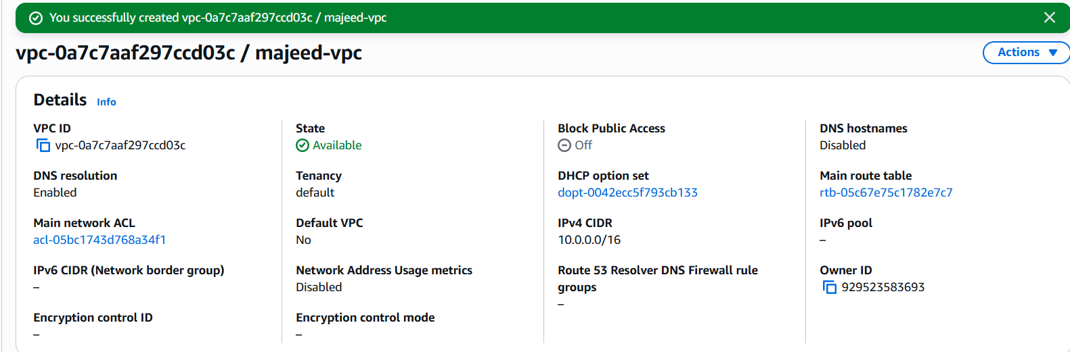

2: Create two subnets: one public subnet and one private subnet.
Open VPC → Subnets.
Click Create subnet.
Select VPC: majeed-vpc
Create the first subnet:
- Subnet name: majeed-public-subnet
- Availability Zone: choose one AZ, for example us-east-1a
- IPv4 subnet CIDR: 10.0.1.0/24
Click Add new subnet.
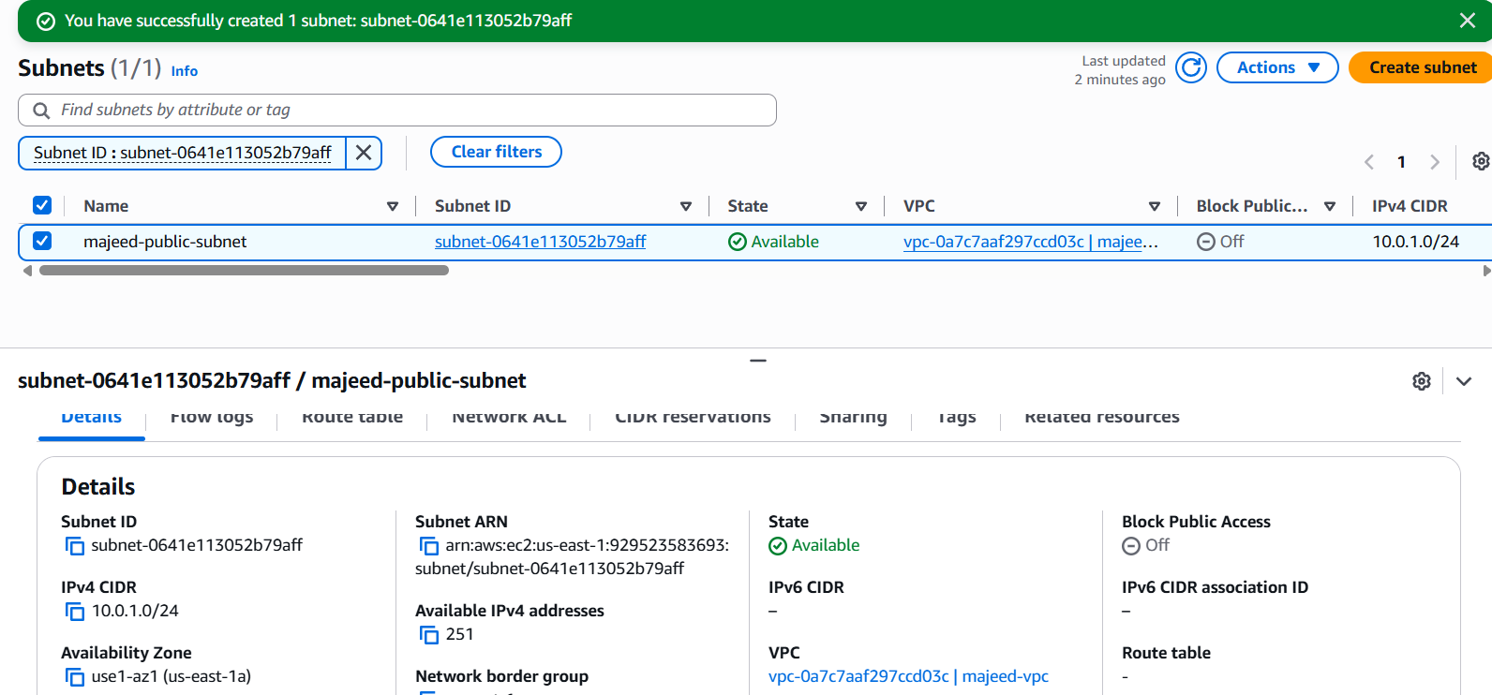
Create the second subnet:
- Subnet name: majeed-private-subnet
- Availability Zone: same AZ, us-east-1a
- IPv4 subnet CIDR: 10.0.2.0/24
Click Create subnet.
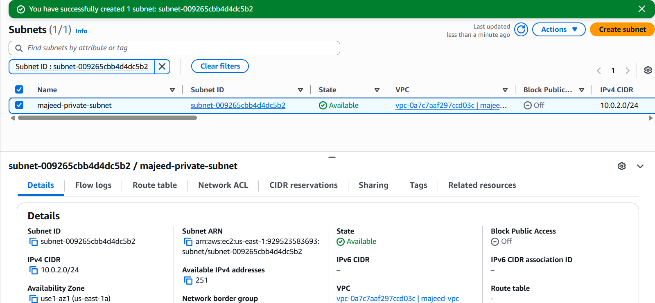

3: Attach an IGW to the VPC.
Steps:
- Open AWS Console → VPC.
- Go to Internet Gateways.
- Click Create internet gateway.
- Enter the name: majeed-igw.
- Click Create internet gateway.
- Select majeed-igw.
- Click Actions → Attach to a VPC.
- Select majeed-vpc.
- Click Attach internet gateway.
- Verify the IGW state shows Attached.
Result:
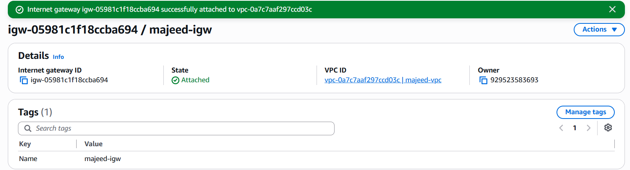

4: Create one public route table (RT) and one private route table.
Create Public Route Table
- Open VPC → Route Tables.
- Click Create route table.
- Enter:
  - Name: majeed-public-rt
  - VPC: majeed-vpc
- Click Create route table.
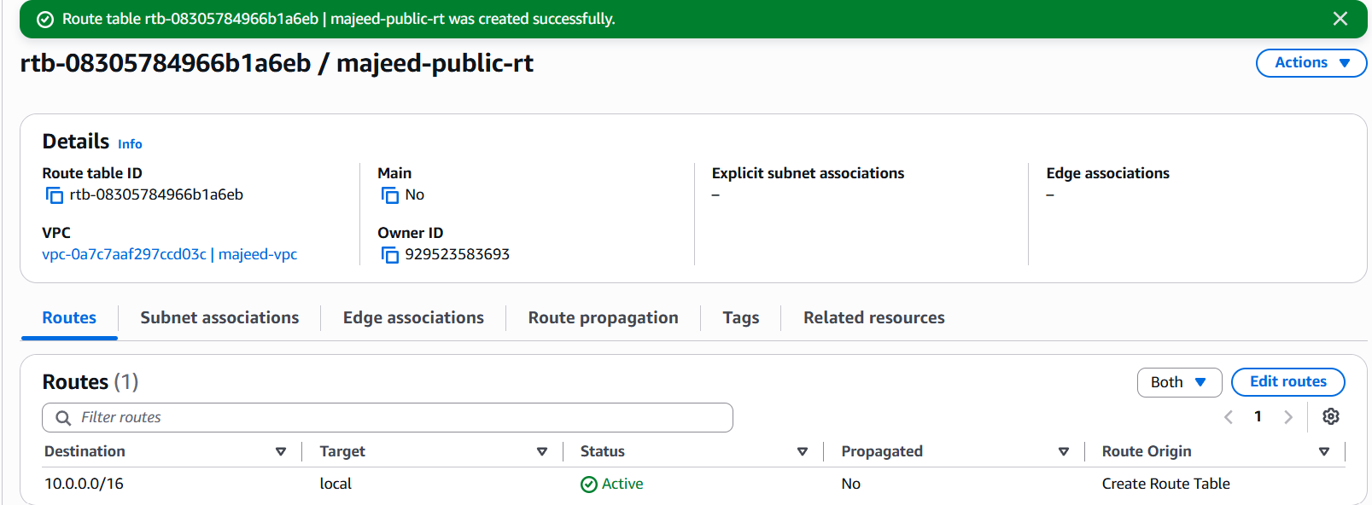
Create Private Route Table
- Click Create route table again.
- Enter:
  - Name: majeed-private-rt
  - VPC: majeed-vpc
- Click Create route table.
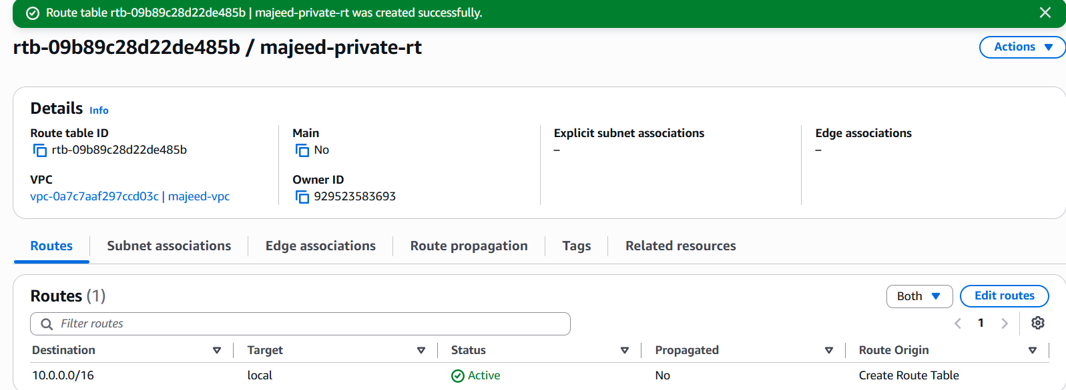

5: Deploy a NAT gateway in the public subnet and attach the NAT gateway to the private subnet.
Deploy a NAT Gateway in the Public Subnet
Steps:
- Open AWS Console → VPC → NAT Gateways.
- Click Create NAT gateway.
- Enter the name: majeed-nat-gateway.
- Select Availability mode: Zonal.
- Select VPC: majeed-vpc.
- Select Subnet: majeed-public-subnet.
- Select Connectivity type: Public.
- Click Allocate Elastic IP.
- Verify the EIP allocation ID: eipalloc-058a18b6f23e318ea.
- Click Create NAT gateway.
- Wait until the NAT Gateway state becomes Available.
Purpose: A public NAT Gateway allows resources in a private subnet to access the Internet for outbound connections without allowing direct inbound Internet connections.
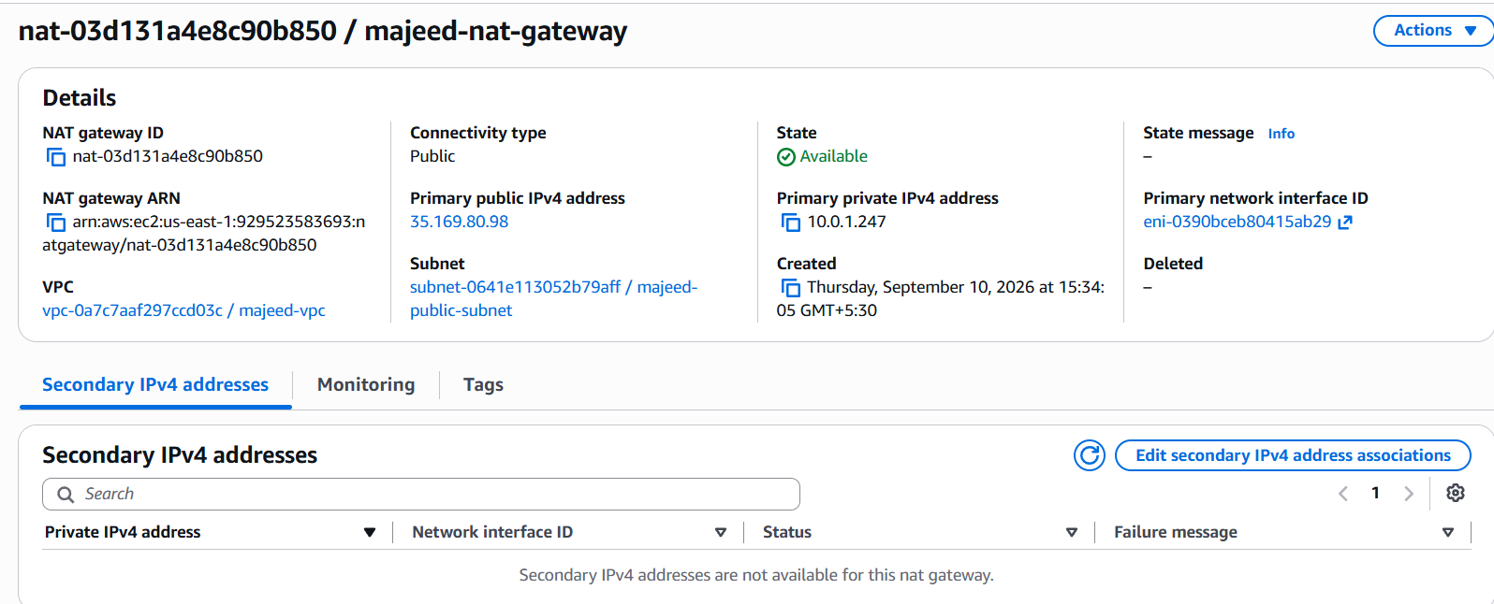
- Configure NAT Gateway and Associate Private Subnet
Part 1: Configure Private Route Through NAT Gateway
- Go to AWS Console → VPC → Route Tables.
- Select majeed-private-rt.
- Open the Routes tab.
- Click Edit routes.
- Click Add route.
- For Destination, enter:
0.0.0.0/0
- For Target, select NAT Gateway.
- Select:
nat-03d131a4e8c90b850 (majeed-nat-gateway)
- Click Save changes.
- Verify the route shows:
0.0.0.0/0 → nat-03d131a4e8c90b850 — Active
Part 2: Associate Private Route Table with Private Subnet
- Stay on majeed-private-rt.
- Open Subnet associations.
- Click Edit subnet associations.
- Select:
majeed-private-subnet
  - Subnet ID: subnet-009265cbb4d4dc5b2
- Click Save associations.
- Verify Explicit subnet associations (1) shows:
majeed-private-subnet
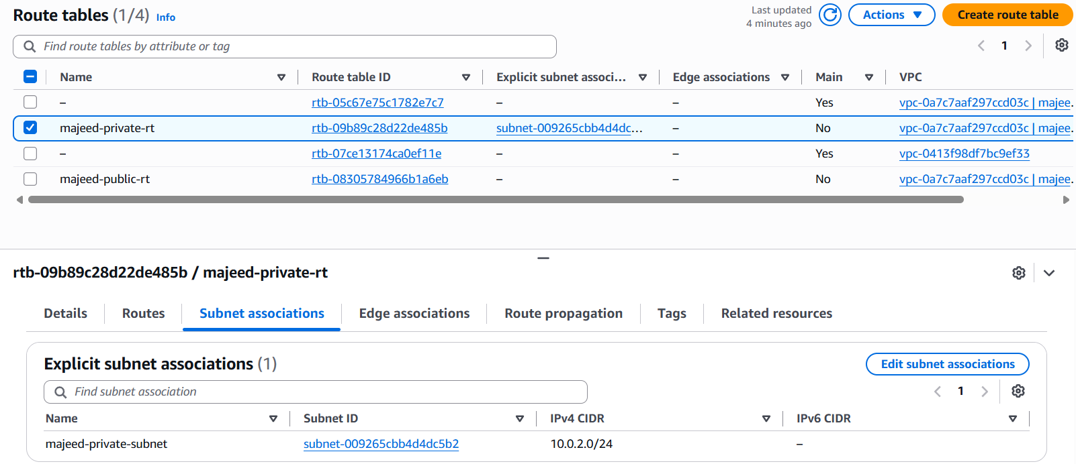

6: Create two instances, one in the public subnet and one in the private subnet.
Public EC2
- Go to EC2 → Launch Instance.
- Create the Public EC2:
  - Name: majeed-public-ec2
  - AMI: Amazon Linux 2023
  - Type: t3.micro
  - VPC: majeed-vpc
  - Subnet: majeed-public-subnet
  - Auto-assign Public IP: Enable
  - Key pair: khan
- Launch the instance and verify Running / 3/3 checks passed.
- Create the Private EC2:
  - Name: majeed-private-ec2
  - AMI: Amazon Linux 2023
  - Type: t3.micro
  - VPC: majeed-vpc
  - Subnet: majeed-private-subnet
  - Auto-assign Public IP: Disable
  - Key pair: khan
- Launch the instance and verify Running / 3/3 checks passed.
Result:
✅ Public EC2 created in the public subnet.
✅ Private EC2 created in the private subnet.
✅ Task 6 completed.
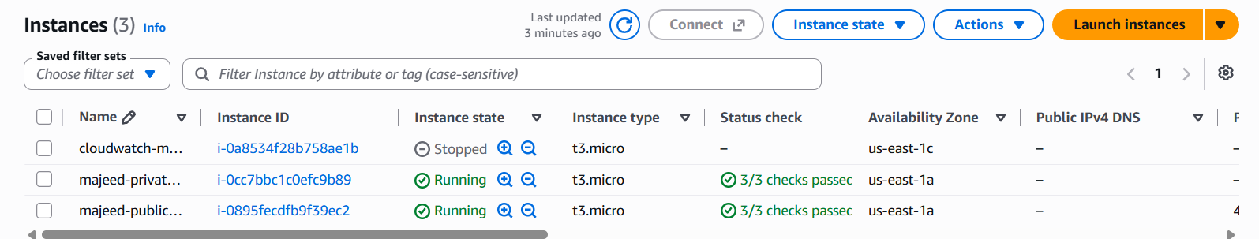

7: Deploy Apache server on both EC2 instances with a sample index.html file.
- Public EC2 Apache Server
- Connect to majeed-public-ec2 using SSH/Git Bash.
- Update packages:
sudo dnf update -y
- Install Apache:
sudo dnf install httpd -y
- Start Apache:
sudo systemctl start httpd
- Enable Apache at boot:
sudo systemctl enable httpd
- Verify Apache:
sudo systemctl status httpd
→ Active: active (running) ✅
- Create the webpage:
sudo vi /var/www/html/index.html
- Added sample HTML:
- <h1>Hello from Public EC2</h1>
<p>Apache Server is running successfully.</p>
- Allowed HTTP (port 80) in the public EC2 security group.
- Tested in browser:
http://44.192.12.232
- Apache webpage displayed successfully ✅
Result: Public EC2 Apache server deployed and verified successfully.

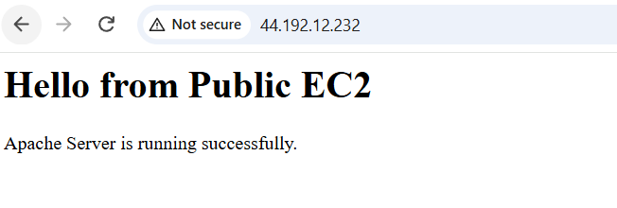
Apache on the private EC2
Objective
Deploy an Apache web server on both EC2 instances and create a sample index.html page.
EC2 Instances
EC2-A – Public EC2
- Private IP: 10.0.1.144
- Role: Public EC2
EC2-B – Private EC2
- Private IP: 10.0.2.236
- Role: Private EC2
Steps Completed on Private EC2
1. Install Apache
sudo dnf install -y httpd
Apache was installed successfully.
2. Start Apache
sudo systemctl start httpd
3. Enable Apache at boot
sudo systemctl enable httpd
4. Check Apache status
sudo systemctl status httpd
Apache was running successfully.
5. Create sample index.html
sudo vi /var/www/html/index.html
The following sample HTML was added:
<!DOCTYPE html>
<html>
<head>
<title>Private EC2 Apache</title>
</head>
<body>
<h1>Hello from Private EC2</h1>
<p>Apache Web Server is running successfully.</p>
<p>Server: 10.0.2.236</p>
</body>
</html>
6. Test Apache locally
curl http://localhost
The custom HTML page was displayed successfully.
7. Test Apache using the private IP
curl http://10.0.2.236
The custom HTML page was displayed successfully.
Connectivity Verification
Private EC2 connectivity was verified using the private IP address.
EC2-A: 10.0.1.144
|
| Private VPC Network
|
v
EC2-B: 10.0.2.236
|
v
Apache Web Server : Port 80
The private EC2 Apache server responded successfully.
Result
- Apache installed successfully on the private EC2.
- Apache service started and enabled.
- Sample index.html created.
- Apache verified using curl.
- Private IP connectivity verified.
- Task 7: COMPLETED ✅

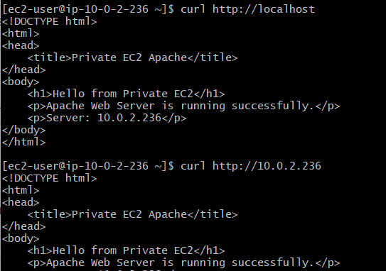
8: Create one application load balancer and attach it to both EC2 instances.
Step 1: Open Target Groups
- Open AWS Console.
- Go to EC2.
- In the left menu, select Target Groups.
- Click Create target group.
Step 2: Target Group Settings
Select:
- Target type: Instances
- Target group name: majeed-apache-tg
- Protocol: HTTP
- Port: 80
- IP address type: IPv4
- VPC: majeed-vpc (10.0.0.0/16)
- Protocol version: HTTP1
Step 3: Health Check
Use:
- Health check protocol: HTTP
- Health check path: /
- Health check port: Traffic port
- Success codes: 200
Leave the other health-check settings as default.
Click Next.
Step 4: Register EC2 Instances
Select both EC2 instances:
- majeed-private-ec2
  - Private IP: 10.0.2.236
  - Port: 80
- majeed-public-ec2
  - Private IP: 10.0.1.144
  - Port: 80
Click Include as pending below.
Step 5: Review
Verify:
- Target group: majeed-apache-tg
- Protocol: HTTP
- Port: 80
- VPC: majeed-vpc
- Targets: 2
Click Create target group.
Result
Target group majeed-apache-tg was created successfully with both EC2 instances registered.
Status: Target Group Created

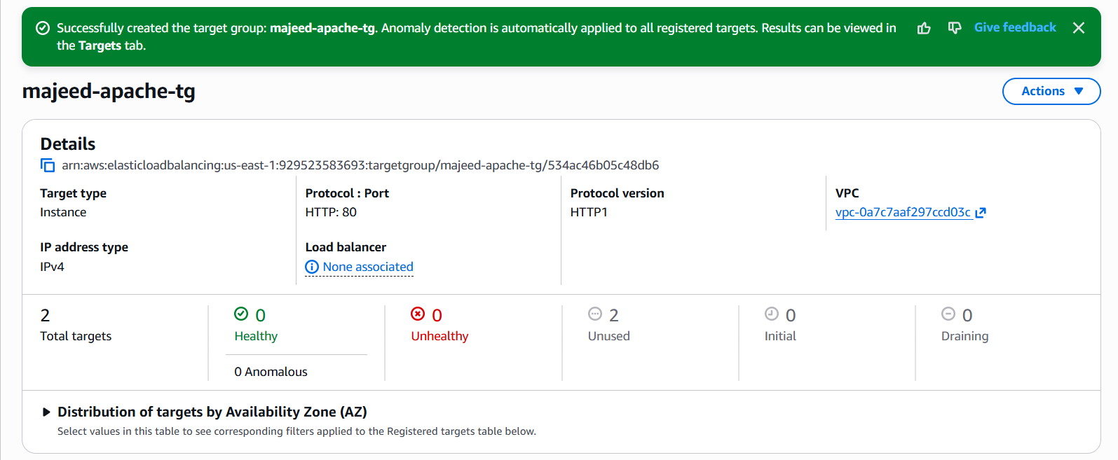
Step 2 – Create Application Load Balancer
- Go to EC2 → Load Balancers.
- Click Create Load Balancer.
- Select Application Load Balancer.
- Basic configuration:
  - Name: majeed-alb
  - Scheme: Internet-facing
  - IP address type: IPv4
Step 3 – Network Mapping
Select:
- VPC: majeed-vpc (10.0.0.0/16)
- Availability Zone: us-east-1a
  - Subnet: majeed-public-subnet
- Availability Zone: us-east-1b
  - Subnet: majeed-alb-subnet-2
Both subnets have an Internet Gateway route.
Step 4 – Security Group
Select:
- default security group in majeed-vpc
Do not select the EC2 security groups for the ALB.
Step 5 – Listener and Routing
Configure:
- Protocol: HTTP
- Port: 80
- Default action: Forward to
- Target group: majeed-apache-tg
Step 6 – Review
Verify:
- ALB name: majeed-alb
- Scheme: Internet-facing
- IPv4
- VPC: majeed-vpc
- Two AZs: us-east-1a and us-east-1b
- Security group: default
- HTTP: 80
- Forward to majeed-apache-tg
Step 7 – Create
Click Create load balancer.
Wait until the ALB status changes from:
Provisioning → Active ✅

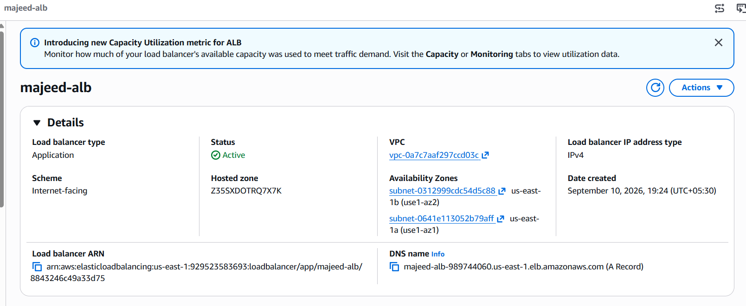
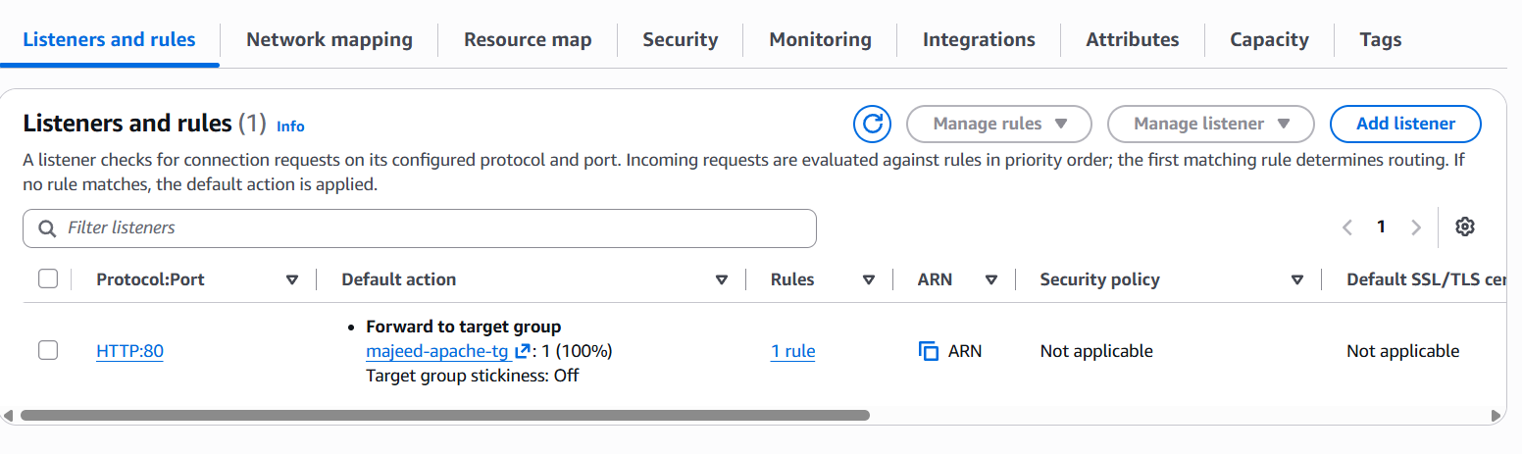
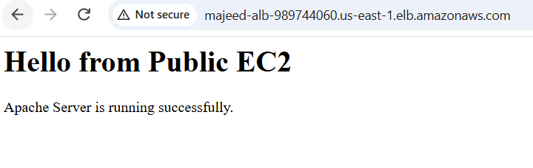
9: Store application load balancer logs in S3.

1. Create S3 Bucket
- Open AWS Console → S3.
- Click Create bucket.
- Bucket name:
majeed-alb-logs-2026
- Region:
US East (N. Virginia) – us-east-1
- Keep Block all public access enabled.
- Keep ACLs disabled.
- Click Create bucket.
Step2. Open ALB Attributes
- Go to EC2 → Load Balancers.
- Select:
majeed-alb
- Open Attributes.
- Click Edit.
- Scroll to the Logging section.
- Under Access logs, enable logging.
- Set the S3 URI:
s3://majeed-alb-logs-2026
Error:
3. Access Denied Error
When saving the ALB configuration, the following error appeared:
InvalidConfigurationRequestException: Access Denied for bucket: majeed-alb-logs-2026
4. Fix S3 Bucket Permission
The ALB needs permission to write access logs to the S3 bucket.
- Go to S3 → majeed-alb-logs-2026.
- Open Permissions.
- Find Bucket policy.
- Add the following policy:
{
"Version": "2012-10-17",
"Statement": [
{
"Sid": "AllowALBAccessLogs",
"Effect": "Allow",
"Principal": {
"Service": "logdelivery.elasticloadbalancing.amazonaws.com"
},
"Action": "s3:PutObject",
"Resource": "arn:aws:s3:::majeed-alb-logs-2026/*"
}
]
}
- Click Save changes.
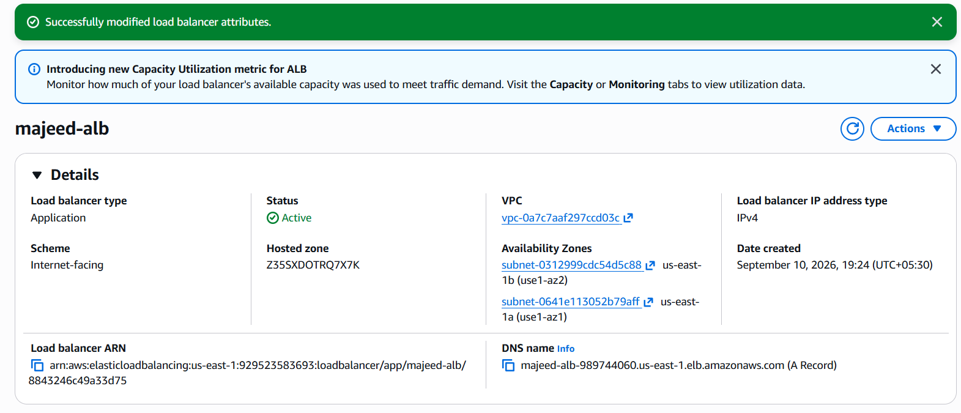
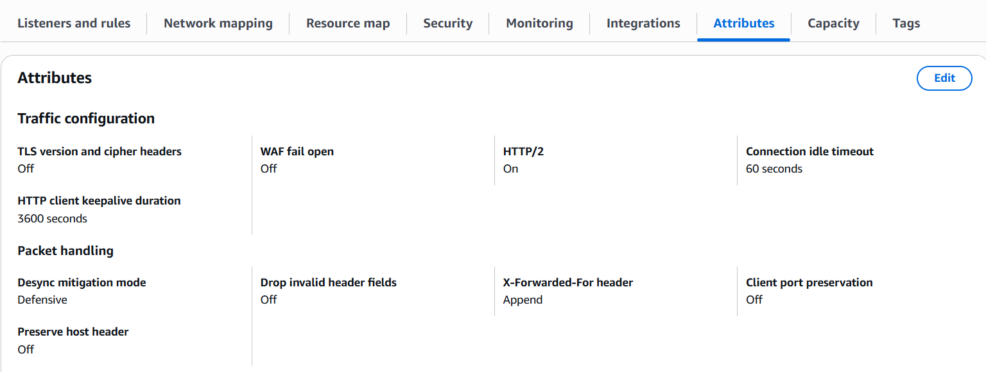
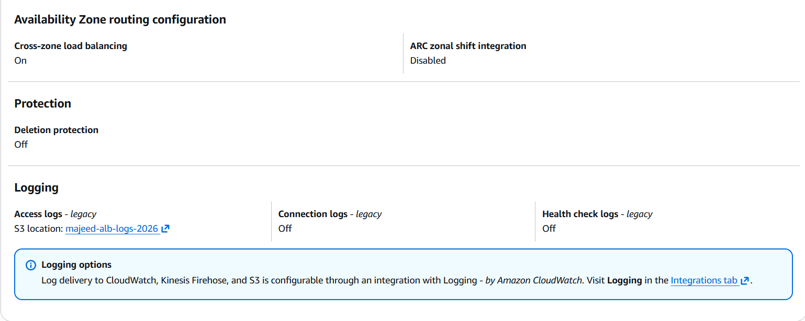
The important line is:
Access logs – legacy
S3 location: majeed-alb-logs-2026
This confirms Access Logs are enabled and configured to store logs in your S3 bucket.

10: Store the VPC flow logs in a CloudWatch log group.
objective:
Store VPC network traffic logs in CloudWatch for monitoring and troubleshooting.
steps:
- Create CloudWatch log group
Go to:
CloudWatch → Log groups → Create log group
Name:
majeed-vpc-flow-logs
- Create VPC flow log
Go to:
VPC → Your VPCs → select majeed-vpc
Click:
Actions → Create flow log
- Flow log settings
- Name: majeed-vpc-flow-log
- Filter: All
- Maximum aggregation interval: 10 minutes
- Destination
Select:
Send to CloudWatch Logs
Destination log group:
majeed-vpc-flow-logs
- Service access
Select:
Create and use a new service role
Service role name:
vpc-flow-logs-role
- Log format
Select:
AWS default format
Leave additional metadata and EC2 tag fields unchecked.
- Create
Click Create flow log.
verification:
- state: Active
- destination: cloud-watch-logs
- traffic type: All
- log group: majeed-vpc-flow-logs
- IAM role: vpc-flow-logs-role
result:
VPC flow logs → CloudWatch → majeed-vpc-flow-logs
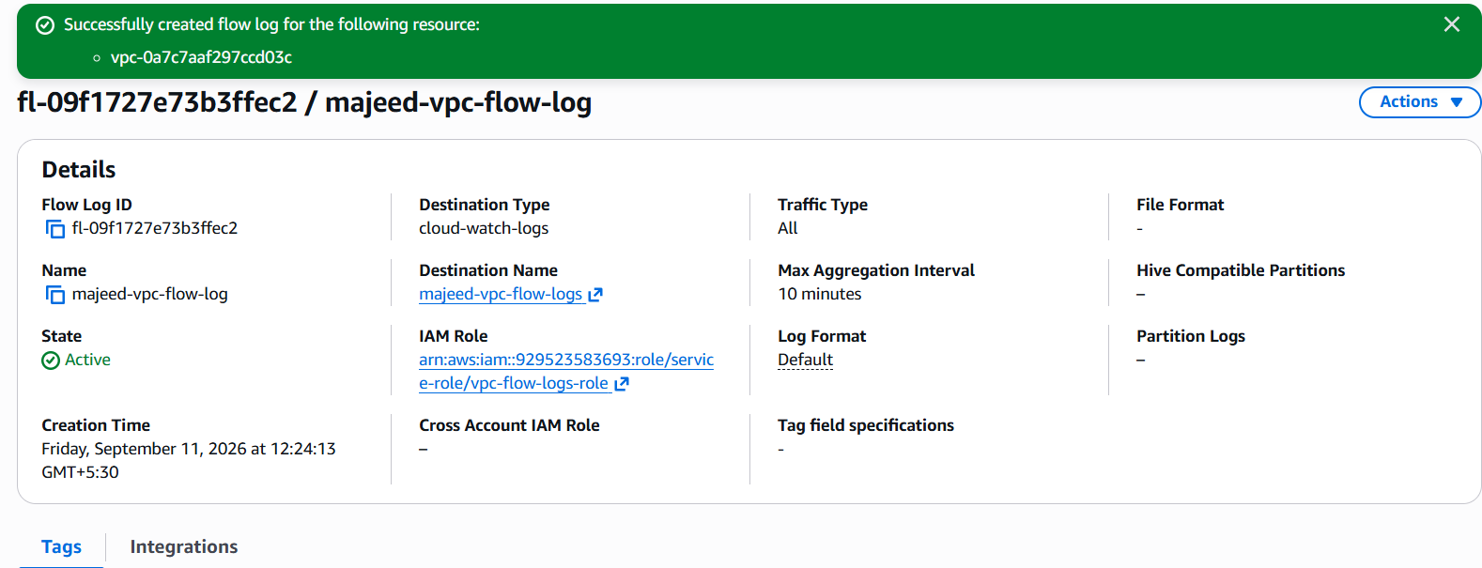

11: Create monitoring dashboards to monitor CPU utilization and to monitor the Apache service.
Objective:
Create a CloudWatch dashboard to monitor EC2 CPU utilization and Apache service.
Steps performed:
- Opened CloudWatch → Dashboards.
- Created dashboard named apache-monitoring-dashboard.
- Added CPUUtilization metrics for:
  - majeed-public-ec2
  - majeed-private-ec2
- Installed and configured Amazon CloudWatch Agent on the private EC2.
- Configured procstat to monitor the Apache (httpd) process.
- Attached CloudWatchAgentServerPolicy through the EC2 IAM role.
- Added the procstat_lookup_pid_count metric to the dashboard.
- Verified that the Apache metric started showing data.
Final Result:
✅ CPU utilization monitoring is available for both EC2 instances.
✅ Apache/httpd process monitoring is working.
✅ Dashboard: apache-monitoring-dashboard

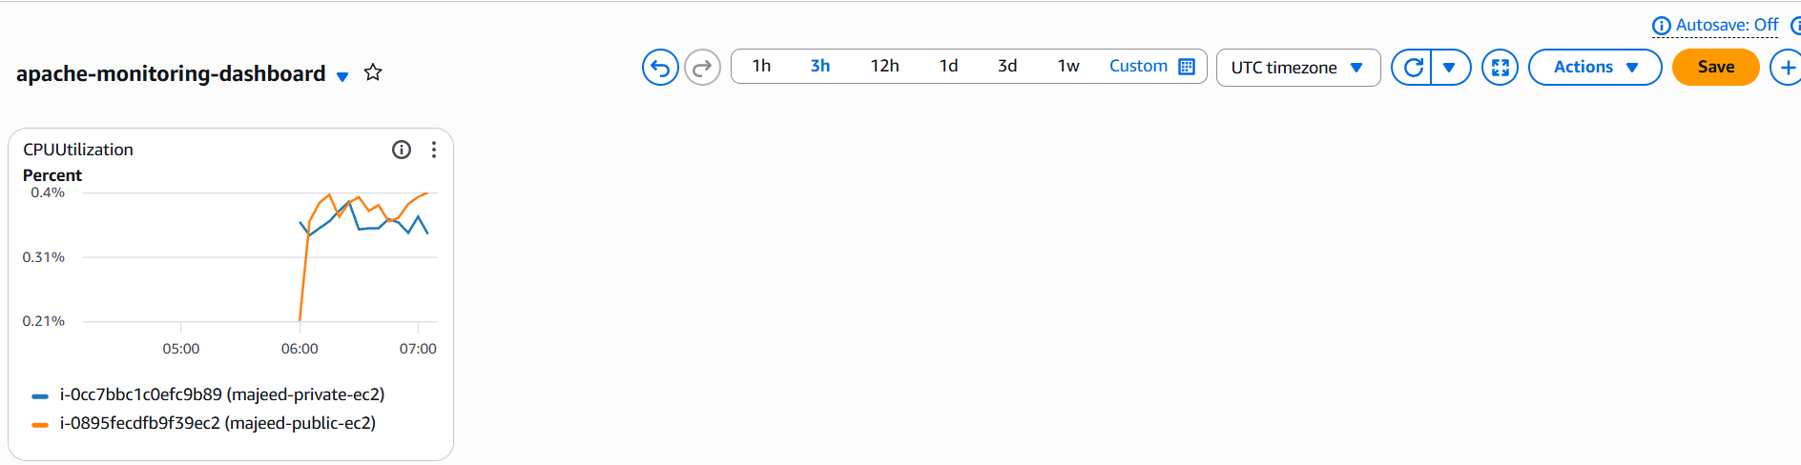
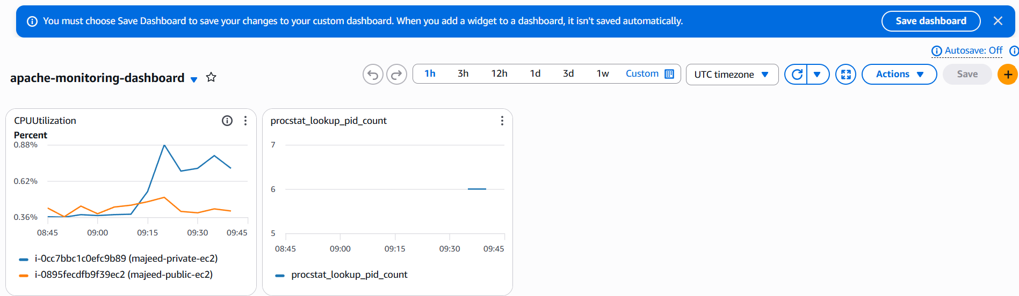

12: If CPU utilization is more than 70%, then it should trigger auto scaling and launch new instance.
Objective
Configure Auto Scaling so that when CPU utilization exceeds 70%, the Auto Scaling Group automatically launches a new EC2 instance.
Steps
1. Create a Launch Template
- Open EC2 → Launch Templates.
- Click Create launch template.
- Launch template name: majeed-asg-template
- Select:
  - AMI: Amazon Linux 2023
  - Instance type: t3.micro
  - Key pair: khan
  - Security group: majeed-public-sg
- Add User Data to automatically install Apache:
#!/bin/bash
yum install -y httpd
systemctl enable httpd
systemctl start httpd
echo "Hello from Auto Scaling EC2" > /var/www/html/index.html
- Create the launch template.
2. Create the Auto Scaling Group
- Open EC2 → Auto Scaling Groups.
- Click Create Auto Scaling group.
- Name: majeed-asg
- Select launch template: majeed-asg-template
- Select VPC: majeed-vpc
- Select the public subnet.
- Configure capacity:
  - Desired capacity: 1
  - Minimum capacity: 1
  - Maximum capacity: 2
- Attach the existing Application Load Balancer target group:
  - majeed-apache-tg
- Create the Auto Scaling Group.
3. Create Dynamic Scaling Policy
- Open majeed-asg → Automatic scaling.
- Click Create dynamic scaling policy.
- Select:
  - Policy type: Target tracking scaling
  - Metric type: Average CPU utilization
  - Target value: 70%
  - Instance warmup: 300 seconds
  - Disable scale in: Unchecked
- Click Create.
The Auto Scaling Group should now show:
Dynamic scaling policies: 1
4. Test Auto Scaling
- Connect to the ASG instance using SSH.
- Generate CPU load:
yes > /dev/null &
yes > /dev/null &
- Monitor CPU utilization in EC2 → Auto Scaling Groups → Monitoring.
- When CPU utilization remains above the 70% target, the target tracking alarm changes to ALARM.
5. Verify Scale-Out
The Auto Scaling activity showed:
Target Tracking Policy changed desired capacity from 1 to 2.
A new EC2 instance was automatically launched:
i-0e135c9cd71c32e1d
This confirmed that Auto Scaling successfully responded to high CPU utilization.
Final Result
✅ Launch Template created
✅ Auto Scaling Group created
✅ Minimum capacity: 1
✅ Desired capacity: 1
✅ Maximum capacity: 2
✅ Target tracking policy: 70% CPU
✅ Instance warmup: 300 seconds
✅ CPU load generated successfully
✅ CPU exceeded 70%
✅ Target tracking alarm triggered
✅ Desired capacity increased from 1 to 2
✅ New EC2 instance launched automatically
Task 12: COMPLETED ✅
